

Phishing Email Analysis & Awareness Report

Prepared by
Mokoena Lebohang Solomon

2026

Contents
Purpose 3
Report aims 4
Email Analysis (4 Samples) 6
Common Phishing Indicators Identified 8
Prevention Guidelines 9
Conclusion 10

Purpose
This awareness report is designed to help employees understand phishing attacks, recognize warning signs, and take appropriate action to prevent security incidents.
What is Phishing?
Phishing is a cyber attack where attackers trick users into clicking malicious links, downloading harmful files, or sharing sensitive information such as passwords or one-time pins (OTPs).
Phishing Attack Flow
The diagram below shows how a typical phishing attack happens step by step:
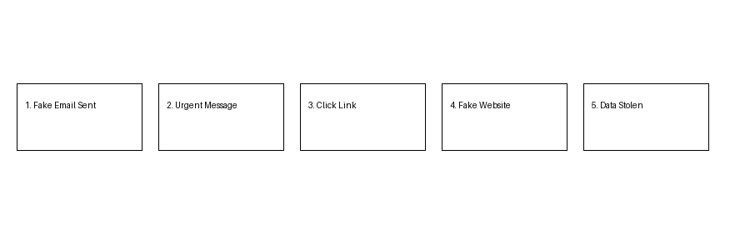
How Phishing Attacks Work
- Attacker sends a fake email pretending to be trusted
- Creates urgency or excitement
- User clicks a link or opens attachment
- Sensitive data is stolen OR malware is installed

Report aims to:
- Analyze multiple phishing email samples
- Identify common phishing techniques
- Classify email risks
- Educate employees in simple, clear language
- Provide practical prevention strategies

Collect Phishing Email Samples
Four phishing email examples were selected based on common real-world attacks:
- Account verification scam
- Banking alert scam
- Invoice/payment scam
- Job offer scam

Analyze Email Headers
Using tools like:
- Google Admin Toolbox Messageheader
- MXToolbox
Findings:
- Sender domains often do not match official domains
- Emails are often sent from unknown or spoofed servers
- Reply-to addresses differ from sender addresses
Conclusion: Headers confirm emails are not from legitimate sources

Inspect Sender Domains & Links
- Links redirect to fake websites
- Domains often include:
  - Misspellings (e.g., paypaI instead of paypal)
  - Extra words (secure-login, verify-account)
- Many links use HTTP instead of HTTPS

Email Analysis (4 Samples)

📧 Email 1: Account Verification Scam
Subject: Urgent: Your Account Will Be Locked
Indicators:
- Generic greeting (“Dear User”)
- Urgent language
- Suspicious link: secure-account-verify[.]com
Explanation:
The attacker pressures the user to click a fake verification link to steal login details.

Email 2: Banking Alert Scam
Subject: Suspicious Transaction Detected
Message Summary:
Claims unusual activity and asks user to “secure account immediately”
Indicators:
- Fake bank email address
- Urgency and fear tactics
- Link redirects to fake banking login page
Explanation:
User is tricked into entering banking credentials on a fake website.

Email 3: Invoice / Payment Scam
Subject: Invoice Attached – Payment Required
Message Summary:
Requests payment for an unknown invoice
Indicators:
- Unexpected attachment
- Unknown sender
- No prior business relationship
Explanation:
Attachment may contain malware or ransomware.

Email 4: Job Offer Scam
Subject: Job Opportunity – Immediate Hiring
Message Summary:
Offers high-paying job with minimal requirements
Indicators:
- Too-good-to-be-true offer
- Requests personal information
- Non-professional email address
Explanation:
Attacker collects personal data for identity theft.

Common Phishing Indicators Identified
Across all emails:
*Suspicious sender addresses
*Urgent or threatening language
*Fake or misleading links
*Generic greetings
*Unexpected attachments
*Requests for sensitive information

Prevention Guidelines
DO’s
- Verify sender email addresses carefully
- Hover over links before clicking
- Confirm requests via official channels
- Report suspicious emails immediately
- Use strong passwords and MFA

DON’Ts
- Do NOT click unknown links
- Do NOT download unexpected attachments
- Do NOT share passwords or OTPs
- Do NOT trust urgent messages blindly

Organizational Recommendations
- Conduct regular phishing awareness training
- Implement email filtering systems
- Enable Multi-Factor Authentication (MFA)
- Run phishing simulations
- Create clear reporting procedures

Summary
Phishing attacks:
- Target human behavior, not systems
- Are low-cost but highly effective
- Can lead to:
  - Data breaches
  - Financial loss
  - Reputation damage

Conclusion
Phishing remains one of the most dangerous cybersecurity threats because it relies on deception rather than technical vulnerabilities.
The best defense is:
Awareness + Vigilance + Training

